Self-portrait!
- Dibuixa’t en el marc inferior. Després, amb l’ajuda del pares, completa les frases que hi ha a continuació.
- Fes un dibuix de la teva mare, pare… i descriu-los: She/He is…. She/he has…

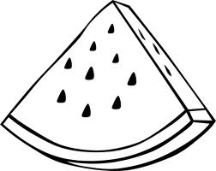
Em dic… My name is ____________________.
Tinc els ulls ... I have ______________________ eyes.
Tinc el cabell … I have _______________ (long/short) and _______________________. (brown/black/blond/red) hair.
Jo sóc… I am ___________ (Tall/short)

